

SIMATS SCHOOL OF ENGINEERING
SAVEETHA INSTITUTE OF MEDICAL AND TECHNICAL SCIENCES
CHENNAI-602105

Assignment: Requirements Engineering and Software Architecture (UNIT – II)

CSA1006 SOFTWARE ENGINEERING
NAME: RAHIMA BANU N SLOT:D
REG NO:192525009 FACULTY NAME: Dr R SURENDRAN

PROBLEM: BloodConnect – Blood Donor Management System

Introduction
BloodConnect is a software solution developed to connect blood donors with patients during emergency situations. The system allows donors to register, patients to search for suitable blood donors, and administrators to verify donor information. This centralized approach reduces the time required to locate blood donors and improves the efficiency of blood donation management.

Problem Statement
During medical emergencies, finding a compatible blood donor quickly is often difficult. Manual methods such as phone calls or social media are time-consuming and unreliable. A Blood Donor Management System helps simplify donor registration, donor search, and request management through a centralized platform.

Objectives
- Develop a centralized blood donor management system.
- Enable donor registration and login.
- Allow patients to search donors based on blood group.
- Facilitate blood request management.
- Ensure donor information is verified by administrators.

Requirements

Stakeholder | Responsibility
Donor | Registers and responds to blood requests
Patient | Searches donors and sends blood requests
Administrator | Verifies donor information and manages the system

Functional Requirements

ID | Requirement
FR1 | Donor Registration
FR2 | User Login
FR3 | Search Blood Donor
FR4 | Send Blood Request
FR5 | Accept or Reject Request
FR6 | Verify Donor Details

Non-Functional Requirements

ID | Requirement
NFR1 | Secure user authentication
NFR2 | Fast response time
NFR3 | User-friendly interface
NFR4 | Reliable system performance

Use Case Diagram

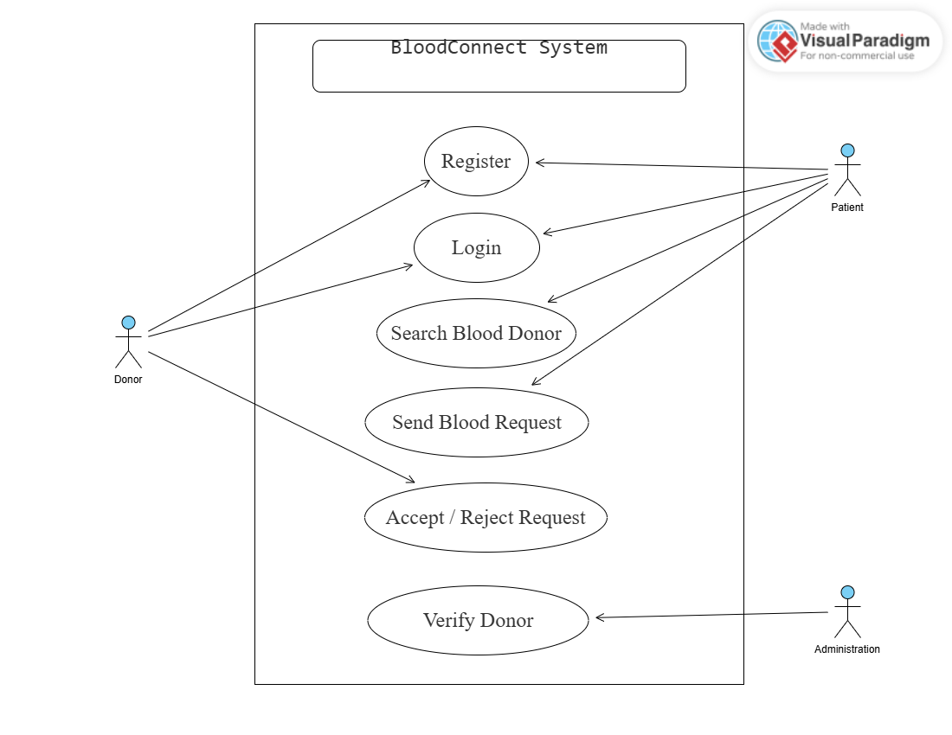

Explanation
The Use Case Diagram illustrates the interactions between the Donor, Patient, and Administrator. It represents the major functionalities of the BloodConnect system, including user registration, login, blood donor search, request handling, and donor verification.

Activity Diagram

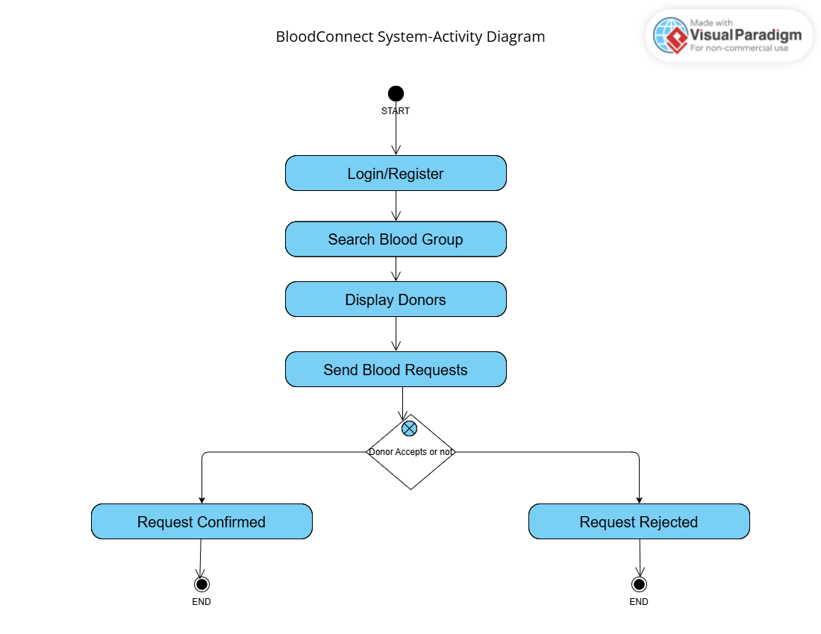

Explanation
The Activity Diagram shows the workflow of the BloodConnect system. It begins with user login or registration, followed by searching for a suitable blood donor, sending a blood request, and confirming the request based on the donor's response. The diagram represents the sequence of activities performed during the blood request process.

Conclusion
The BloodConnect system provides a simple and efficient solution for connecting blood donors with patients during emergencies. By identifying user requirements and representing the system through UML diagrams, the proposed design demonstrates the principles of Requirements Engineering and Software Architecture. The system can be further enhanced by integrating real-time notifications, location-based donor search, and hospital management features.

